Pico device miracast instruction

To mirror the Pico device screen to an TV, please follow the steps below:

1. Get a TV or Laptop with miracast function and enable it.
2. Long press “OK” and “Volume Down” buttons to go to Advanced Setting menu.

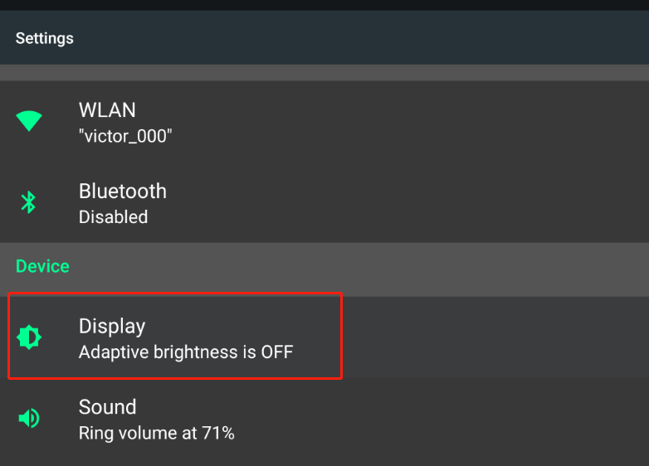

1. Click “Display”, in this menu you will see the option “Cast”.

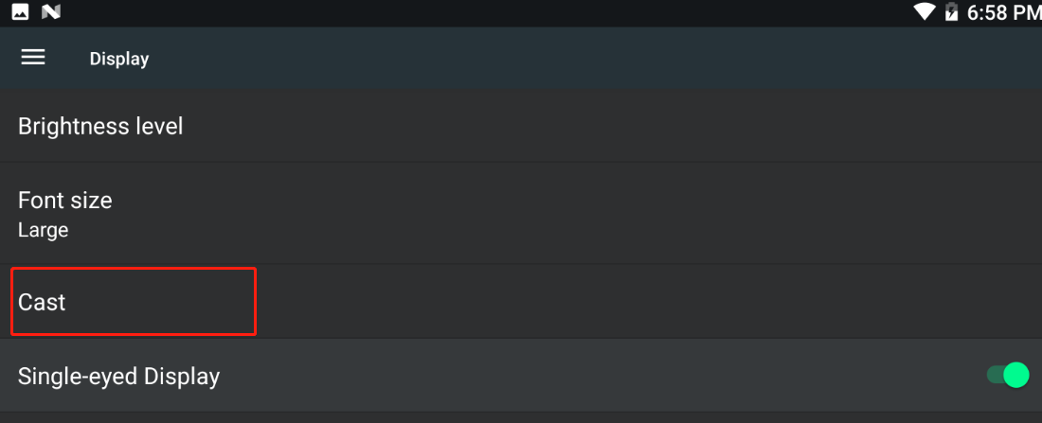

1. In cast page, click the button on right top of the screen and enable all the options. The device will connect to the TV automatically. Normally the pictures will be displayed on TV in 30s.

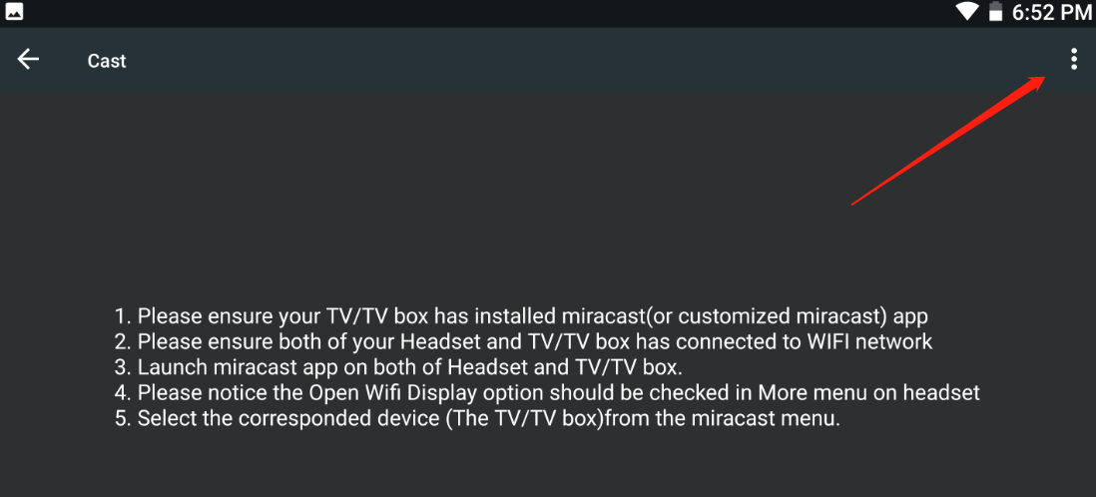

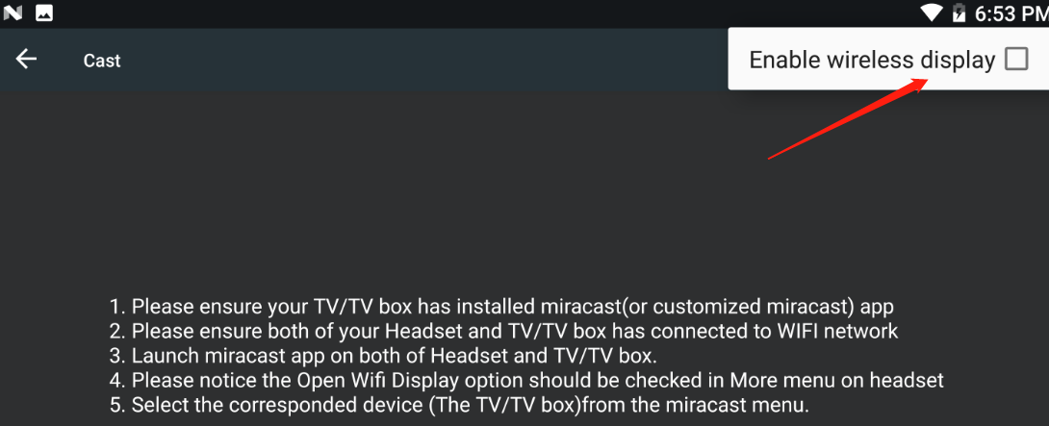

1. If you want to mirror the screen in Single eye mode, please enable “Single-eyed Display” option.

